ASSIGNMENT 4

CSA0272 C PROGRAMMING

S.K. LOHIT DEVESHWAR

192211054

1ST QUESTION

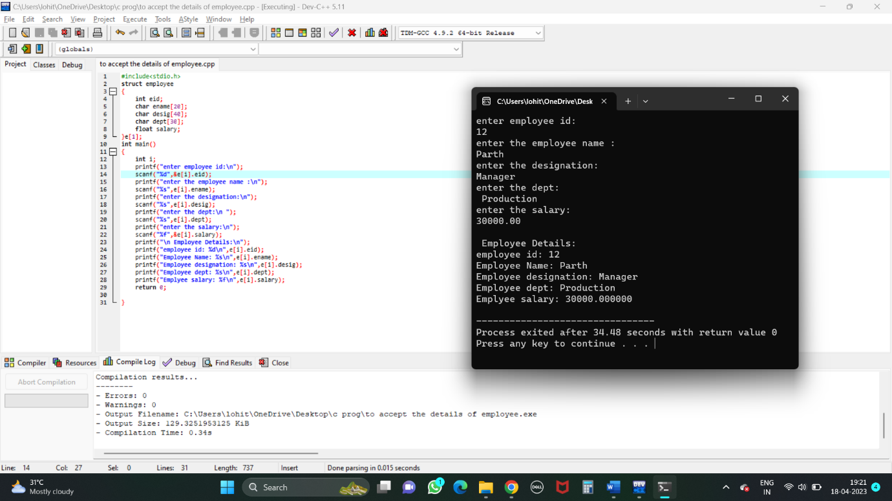

2ND QUESTION

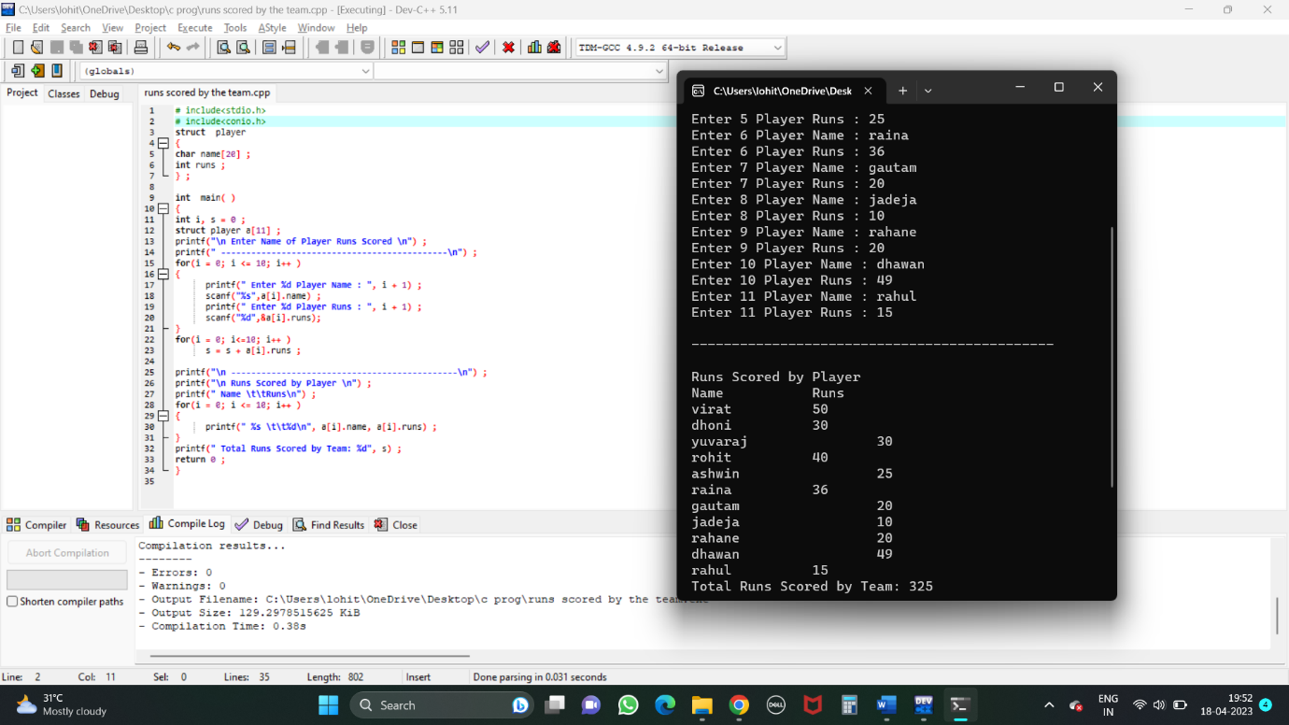

3RD QUESTION

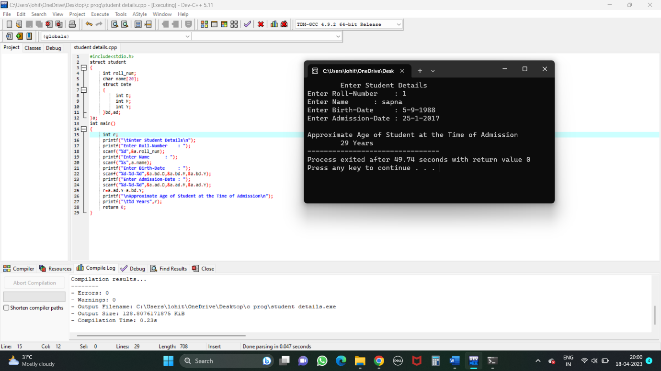

4TH QUESTION

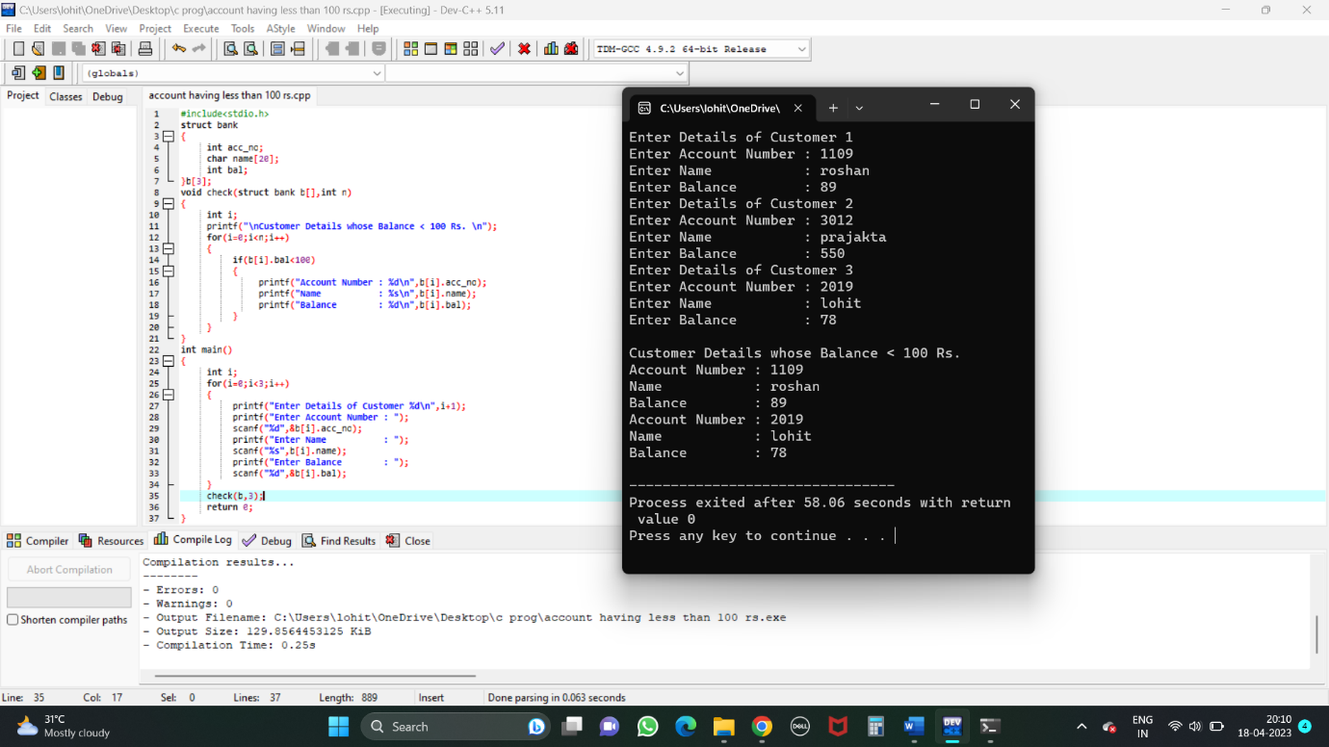

5TH QUESTION

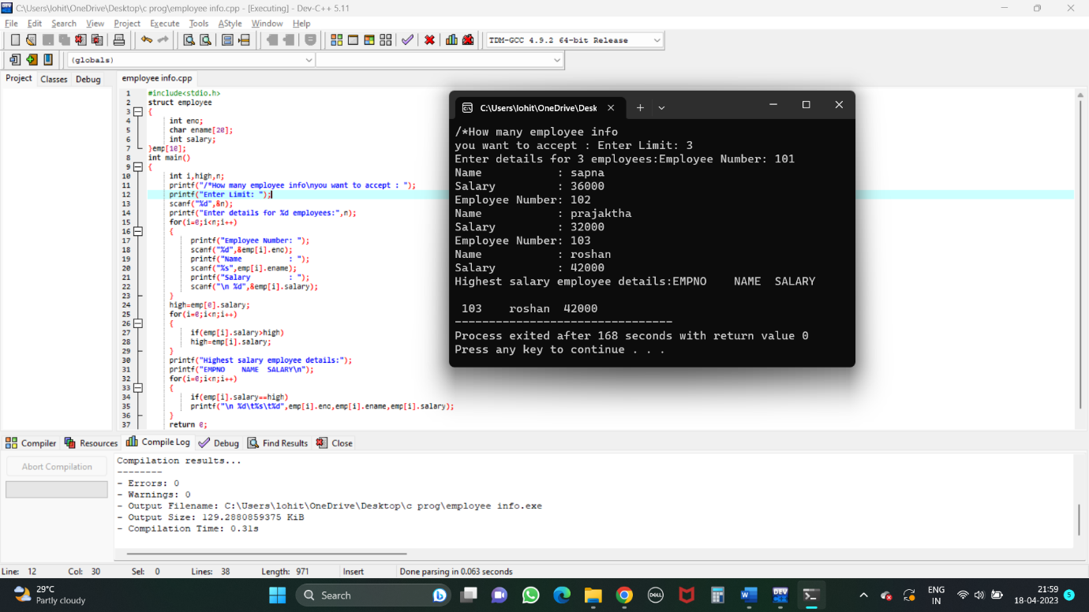

6TH QUESTION

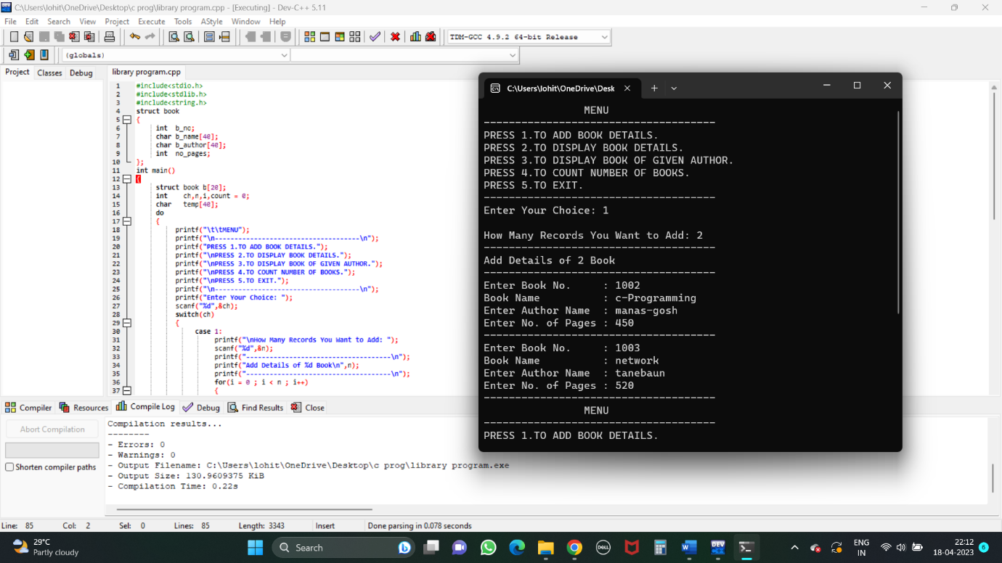

7TH QUESTION

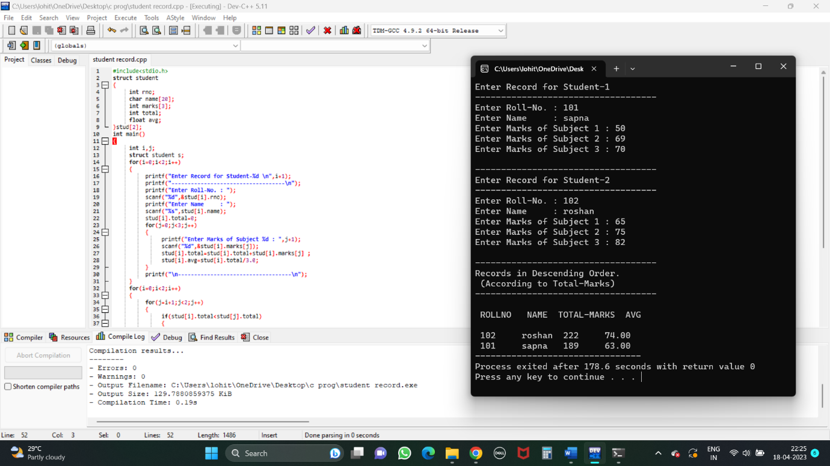

10TH QUESTION

